Enterprise Google Cloud Infrastructure Deployment

Project Setup :

Create a GCP Project

Configure billing

Apply proper naming conventions and labels

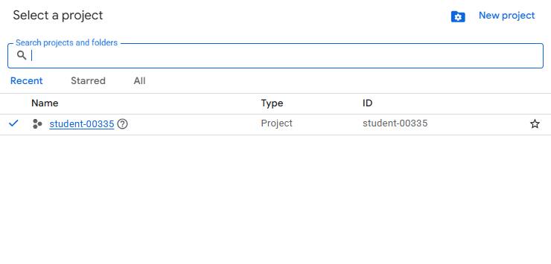

Networking Layer (VPC Design):

Create a VPC Network

Create Subnets in different regions or zones:

Public Subnet

Private Subnet

Configure:

Routes

Firewall Rules

Cloud NAT (for outbound internet access from private instances)
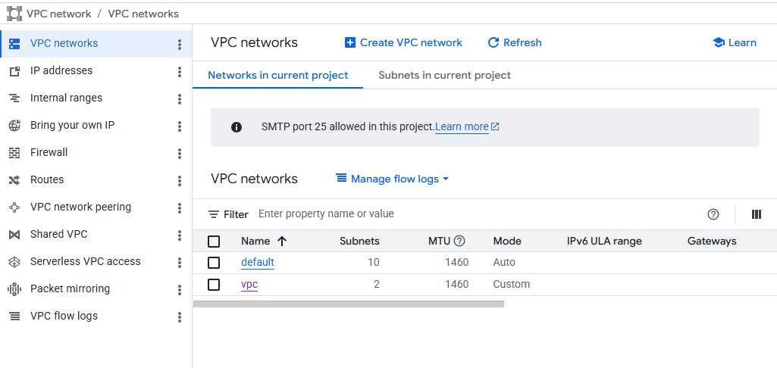
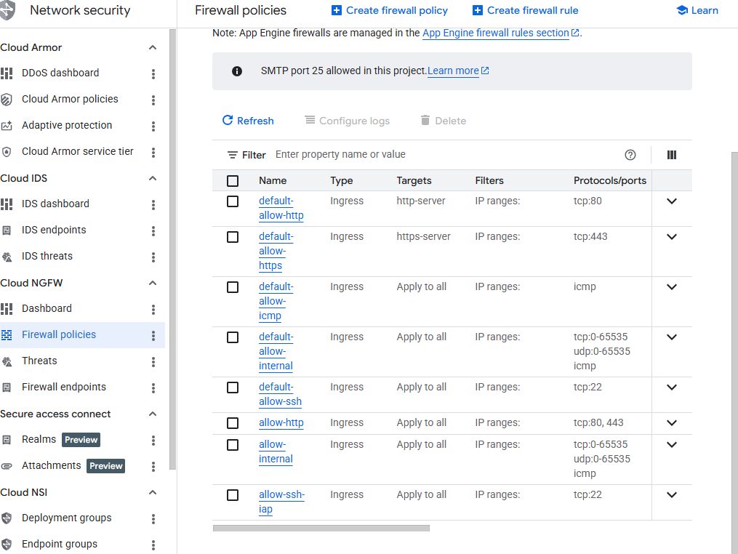
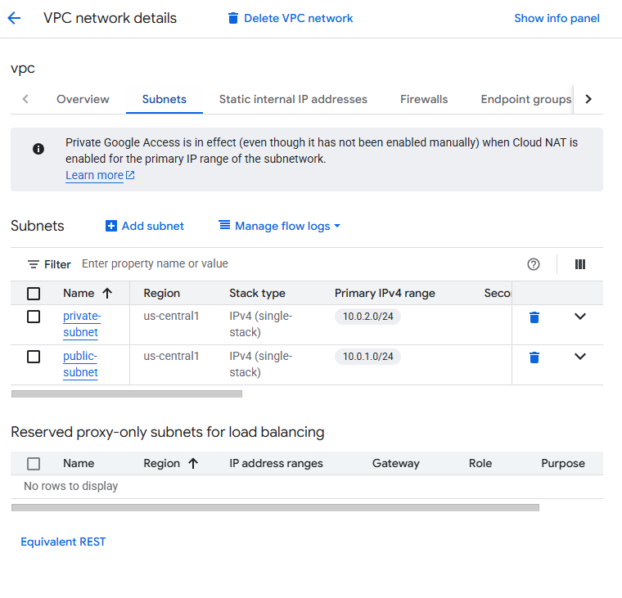

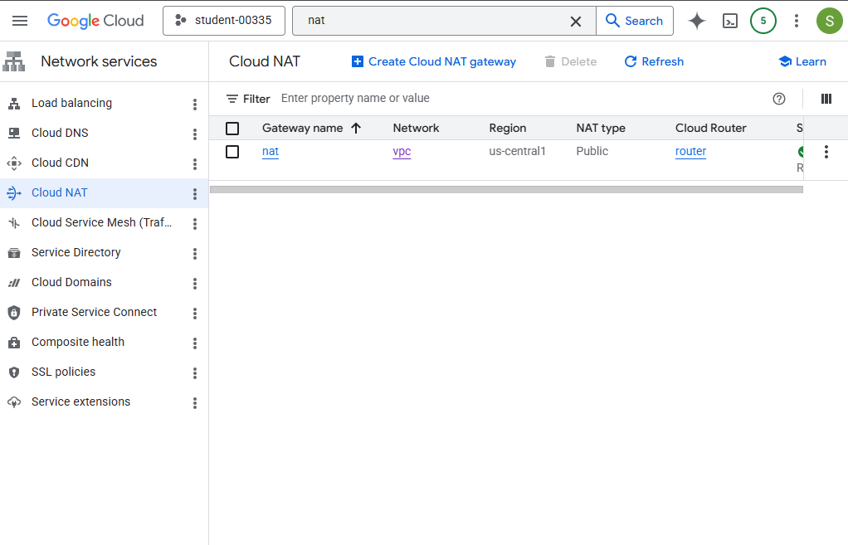

3. Compute Layer:

• Deploy at least 2 Virtual Machines (Compute Engine) in private subnet

• Install a Web Server (Nginx / Apache)

• Ensure instances are not directly exposed to the internet

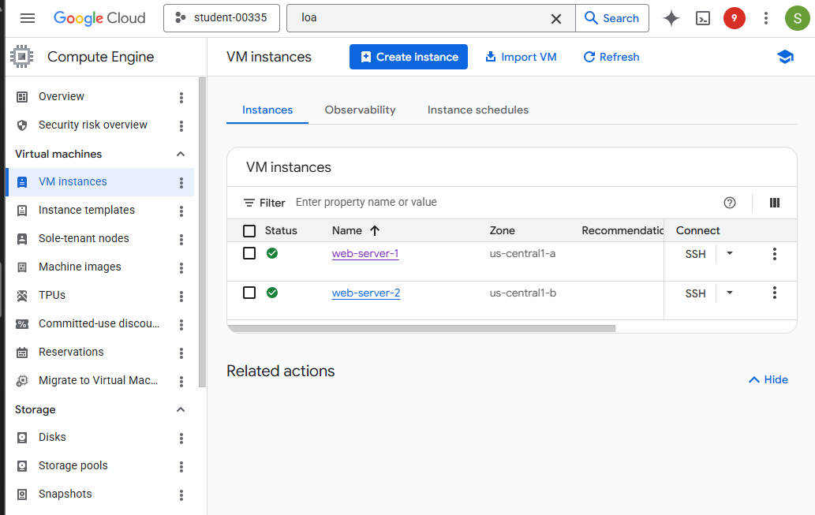

4. Load Balancing:

• Configure an HTTP(S) Load Balancer

• Distribute traffic across instances

• Enable health checks
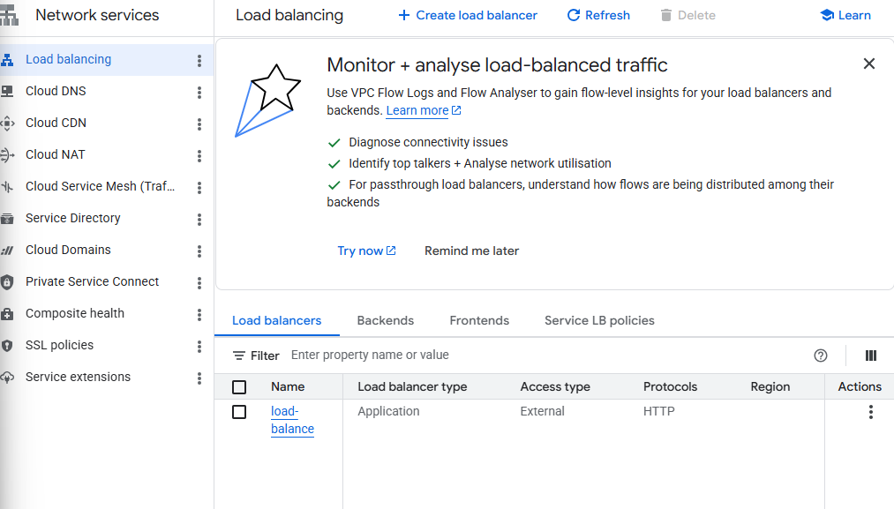
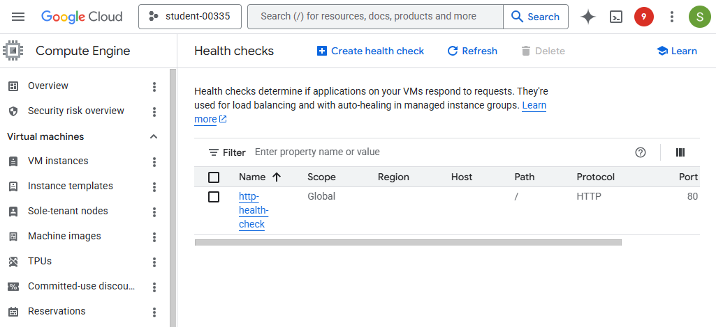

5. Data Layer :
• Deploy a managed database using Cloud SQL (MySQL / PostgreSQL)
• Disable public access
• Allow access only from internal network

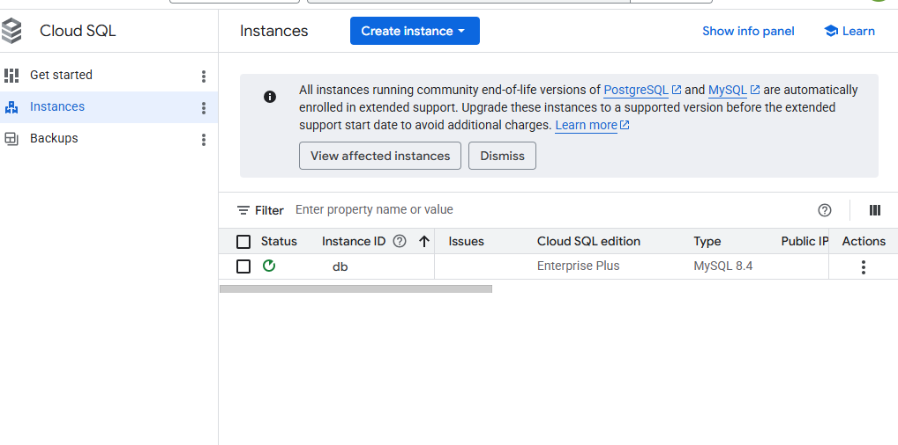

6. Security :

• Configure:

Firewall rules (ingress/egress)

Service Accounts

• Use:

Secret Manager to store credentials

• Apply:

Least Privilege Principle
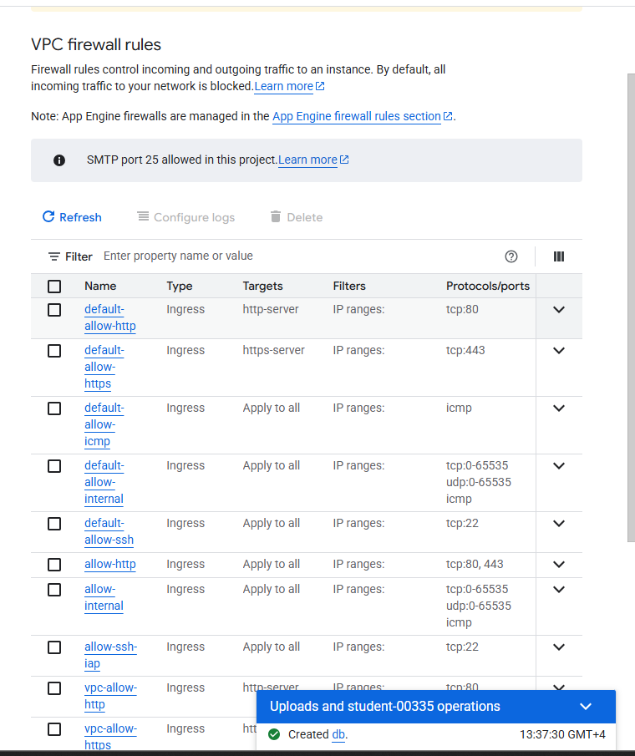

7. Monitoring & Logging:

• Enable:

Cloud Monitoring

Cloud Logging

• Create at least one alert (e.g., high CPU usage)
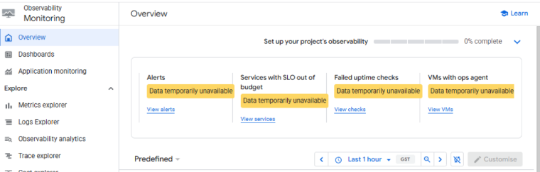
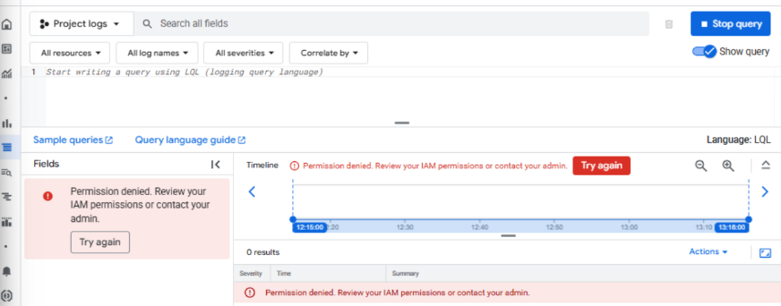

8. Automation (Mandatory) :

• Deploy infrastructure using:

Terraform
